

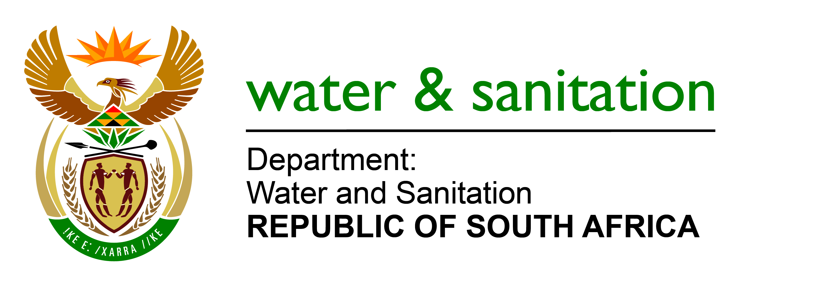

**SUSTAINABLE DEVELOPMENT GOAL 6**

**Target 6.2: Sanitation and Hygiene Gap Analysis Report 2018**

**Target 6.2**:

*“By 2030, achieve access to adequate and equitable sanitation and hygiene for all and end open defecation, paying special attention to the needs of women and girls and those in vulnerable situations.”*

**1 Introduction**

Provision of decent and appropriate sanitation to all South Africans is a Constitutional requirement provided for in Section 24 of the South African Constitution (Act no 108 of 1996) which states that “Everyone has the right to an environment that is not harmful to their health or well-being and to have the environment protected, for the benefit of present and future generations, through reasonable legislative and other measures that prevent pollution and ecological degradation.”

The Water Services Act, 1997 (Act no 108 of 1997) is the legislative instrument by which the South African government aims to fulfil the above Constitutional requirement, section 3 (1) of this Act states that everyone has a right of access to basic water supply and basic sanitation and every water services institution must take reasonable measures to realise these rights.

Schedule 4B of the Constitution provides that water and sanitation services limited to potable water supply systems and domestic waste-water and sewage disposal systems is the function of local government. However, the national government and provincial governments, by legislative and other measures, must support and strengthen the capacity of municipalities to manage their own affairs, to exercise their powers and to perform their functions, (Sec 154 (1) of the Constitution).

In South Africa, local government matters are the responsibility of the Ministry of Cooperative Governance and Traditional Affairs. It is this Ministry that designate municipalities the authority to discharge water and sanitation function i.e. to be Water Services Authorities. There are currently 144 Water Services Authority municipalities plus 8 metros that are providing water and sanitation services.

The National Development Plan, also known as vision 2030 binds the country to provide adequate sanitation services to every South African by year 2030 which is in line with the SDG targets.

**2. Sources of Sanitation Funding.**

Basic sanitation services provision in South Africa is funded through various grants from the national fiscusas shown in the table below.

|  |  |  |  |
| --- | --- | --- | --- |
| **Funding Source** | **2018/19** | **2019/20** | **2020/21** |
| MIG | R15,3 bn | R15,7 bn | R16,6 bn |
| HSDG | R18,2 bn | R18,8 bn | R20,1 bn |
| MIG (Metros) | R294 m | R310 m | R327 m |
| WSIG (Direct) | R2 bn | R2,1 bn | R2,2 bn |
| WSIG (Indirect) | R2.9 bn | R3 bn | R3,2 bn |

Although the grants depicted in the above table do not fund sanitation only, it must be pointed out that sanitation should get a bigger slice of the available budget. There are also amounts of money allocated to fund sanitation provision by the private sector e.g. mines and other companies either for employee facilities or for communities where they are working as part their social investment programmes. Some municipalities that can afford do contribute their own funding to implement a sanitation programme as well.

**3. Sanitation Backlog**

The sanitation backlog can be classified into various categories as follows:

1. Infrastructure Backlog

These are households that have never been served with any government sanitation programme. The majority of these households are in the rural areas and informal settlements.

1. Operation and Maintenance Backlog

This backlog relates to infrastructure that is not serviceable due to lack of maintenance

1. Extension Backlog.

This backlog relates to communities which have been served but due to new additional households being added to that community, these would need to be served as well.

1. Infrastructure Upgrade

This backlog refers to facilities that need to be upgraded to meet the minimum requirements for a basic sanitation facility

1. Resource Needs

Where water resources are needed to support sanitation programme in relation flushing toilets.

The sanitation backlog is estimated at 2 million households, whilst coverage is at about 81% of households.

**4. Current status of functionality of Local Government**

As a developmental state, it is expected that municipalities in South Africa will fulfil the following responsibilities;

* Provide democratic and accountable government for local communities
* Be responsive to the needs of the local community
* Ensure the provision of services to communities in a sustainable manner
* Promote social and economic development
* Promote a safe and healthy environment
* Encourage the involvement of communities and community organisations in the matters of local government
* Facilitate a culture of public service and accountability amongst its staff and
* Assign clear responsibilities for the management and co-ordination of these administrative units and mechanisms.

When the above objectives are adequately met the following outcomes will be achieved.

* The provision of infrastructure and services
* The creation of liveable, integrated and inclusive cities, towns and rural areas
* Local economic development
* Community empowerment and distribution.

These outcomes should create an environment conducive for growth, development and prosperity for local communities and therefore reduce the triple challenges of poverty, unemployment and inequality that are still so prevalent in our communities. These have caused so much frustration and disillusionment which has resulted in wide spread and increasing community protests which are becoming more violent.

**5. Municipal Challenges**

Most of our municipalities especially the Water Services Authorities are faced with a myriad of challenges and the most common ones are:

Lack of human resource capacity

Many municipalities especially the small rural ones have a very poor revenue base and are so dependent on national government grants that they struggle to attract and retain adequately and suitably qualified personnel. Most of senior management posts are either vacant or filled on an acting basis or filled with inadequately qualified individuals. This renders the municipality incapable to deliver quality and sustainable basic services including sanitation.

Poor financial management skills

The Office of the Auditor General has been in the past number of years releasing very negative state of municipal finance management reports and each year the situation is deteriorating instead of improving. The latest AG report on financial management at local government reveals that 86% of municipalities failed to comply with key legislation and this is recorded as the highest non-compliance since 2012-13 financial year. Irregular expenditure increased from R16, 212 billion to R28, 376 billion. Fruitless and wastefulexpenditure amounted to R1, 5 billion a 71% increase from the previous year. Just recently some municipalities invested public monies with a mutual bank against the advice of the Reserve Bank and they run a risk of losing those funds thus negatively impacting basic services delivery.

Flouting of Supply Chain Management Policies

Many municipalities are struggling to comply with supply chain management policies and prescripts resulting in all sorts of procurement challenges and irregularities, which negatively impacts service delivery.

Non-functionality of most Project Management Units

In February 2018, the Department of Cooperative Governance and Traditional Affairs released a report on the evaluation of the effectiveness of Project Management Units at municipalities. These are units that are charged with management of capital projects at different municipalities. The study reveals that there is considerable variation in functionality and efficiency of PMUs across municipalities. It is important to note that where PMUs are inefficient and non-functional services delivery gets negatively affected.

Lack of Good Governance

Good governance implies that good decisions are made and implemented in time by the relevant officials. It also means strict compliance with all relevant legislative prescripts and that there is good accountability and there are consequences for deviant behaviour. Lack of good governance renders the municipality non-functional with dire consequences for service delivery.

Lack of DWS Capacity to Support Local Government

The Department does not have enough capacity to support municipalities to adequately plan, implement, monitor and report progress on sanitation in all the Water Services Authorities in the country. The sanitation component has not been assessed and resourced ever since the mandate of the Department has been changed in 2014.

**6.Current Initiatives to Improve Sanitation Delivery**

Realising that the rate of basic services delivery was slow to meet the 2019 MTSF target, Government established the Project Management Office, coordinated by the Municipal Infrastructure Support Agent (MISA) with the support of the Department of Performance Monitoring and Evaluation (DPME). The main function of the PMO is to coordinate speeding up of basic services delivery in the 27 priority District Municipalities.

The President has also established an Inter-Ministerial Task Team on basic services whose main focus is to facilitate coordination amongst relevant departments to fast track basic services delivery to prioritised 57 municipalities. This IMTT is chaired by the Minister of CoGTA. The IMTT has deployed skilled professional engineers, planners and finance people to the 57 municipalities to help them address service delivery challenges at these struggling municipalities. However this is not enough as the number of poor performing municipalities increase every day. More support is still needed.

**7.Recommendations**

In order to meet target 6.2 of the SDGs the following actions are recommended.

7.1 The Department needs to finalise the proposed structure for Sanitation and fill it up as soon as possible.

7.2 While the sanitation structure is being finalised the Department can procure the services of a Professional Service Provider with sufficient capacity to support municipalities to fast track sanitation service delivery.